WEEK-3
DBS & DBE

========================================================================================
2520030337
Aakash Dadhirao
========================================================================================

- Aim:
To work with MongoDB documents and try out different queries, aggregation stages, embedded data, text search and indexes using the book_metadata collection.
- What I did
- Created/used the book_metadata collection in the bookflow database.
- Checked the documents and their different fields.
- Used $gt and $in queries on reviews.rating.
- Used a regular expression query on format.
- Created an aggregation using $match, $unwind, $group and $sort.
- Created a text index for reviews.comments.
- Tested text search and phrase search.
- Checked the query using explain().

- Collection
The collection contains 5 documents. The documents are not exactly the same, which shows the flexible nature of MongoDB compared to MySQL. Some documents have fields/arrays that are not present in MySQL.

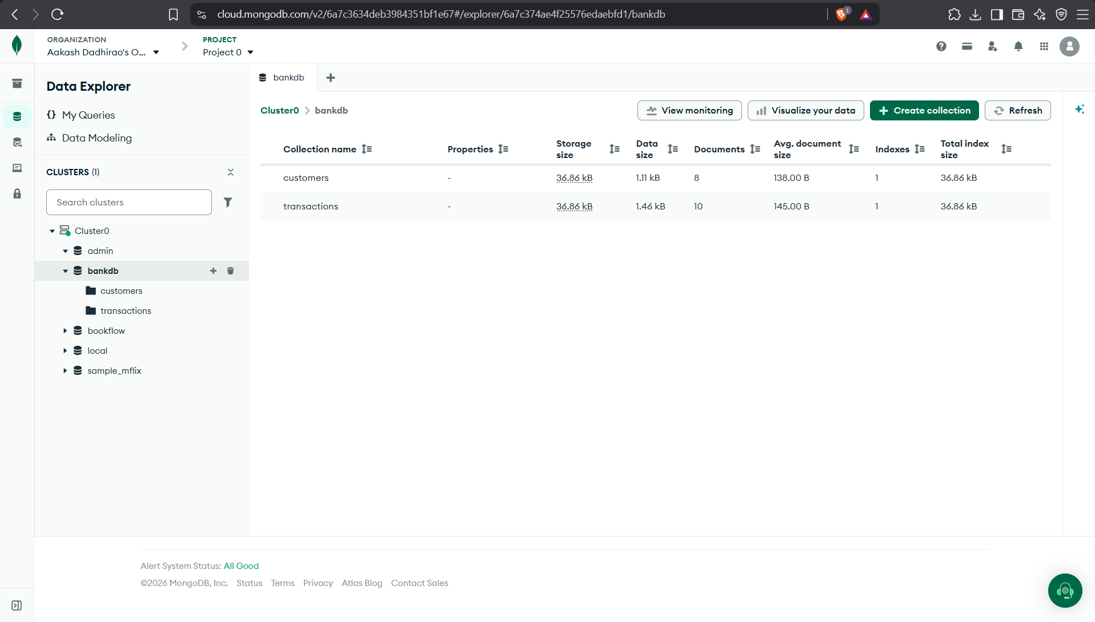

- Document Structure:

The books have normal fields like title, author, published_year, category and format. There are also nested/array fields such as reviews, combat_style and weapons.

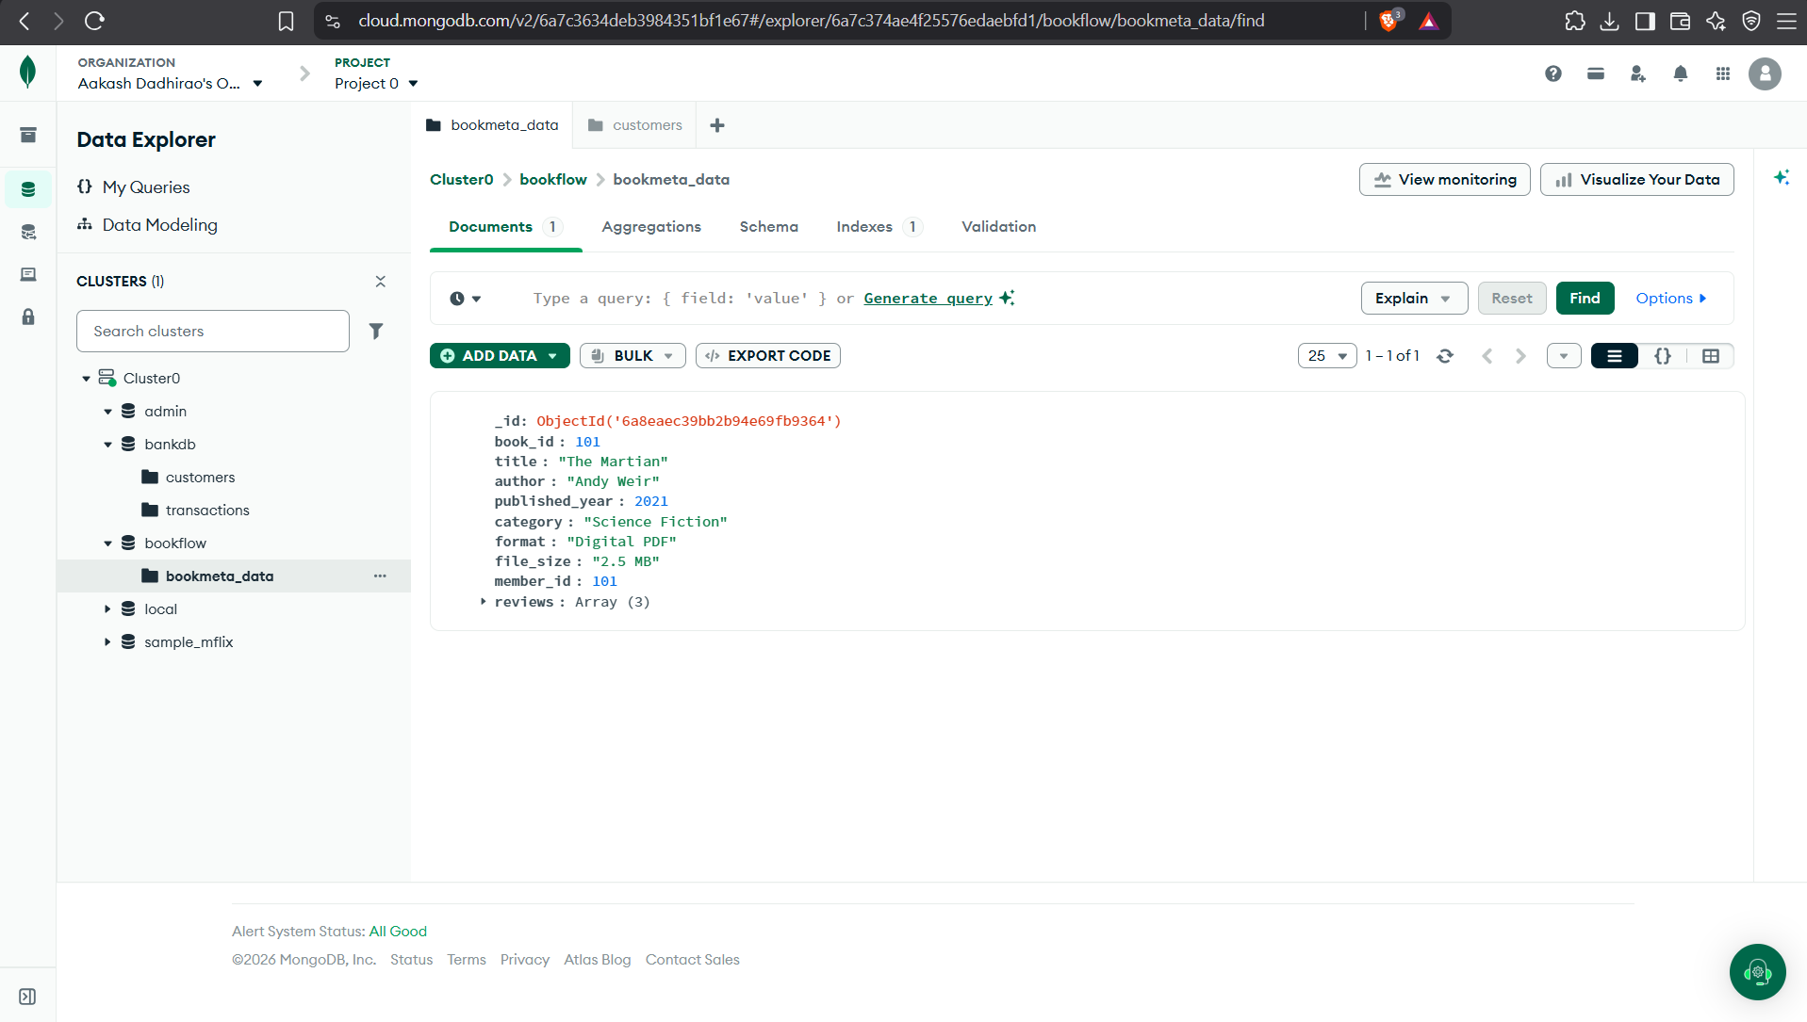

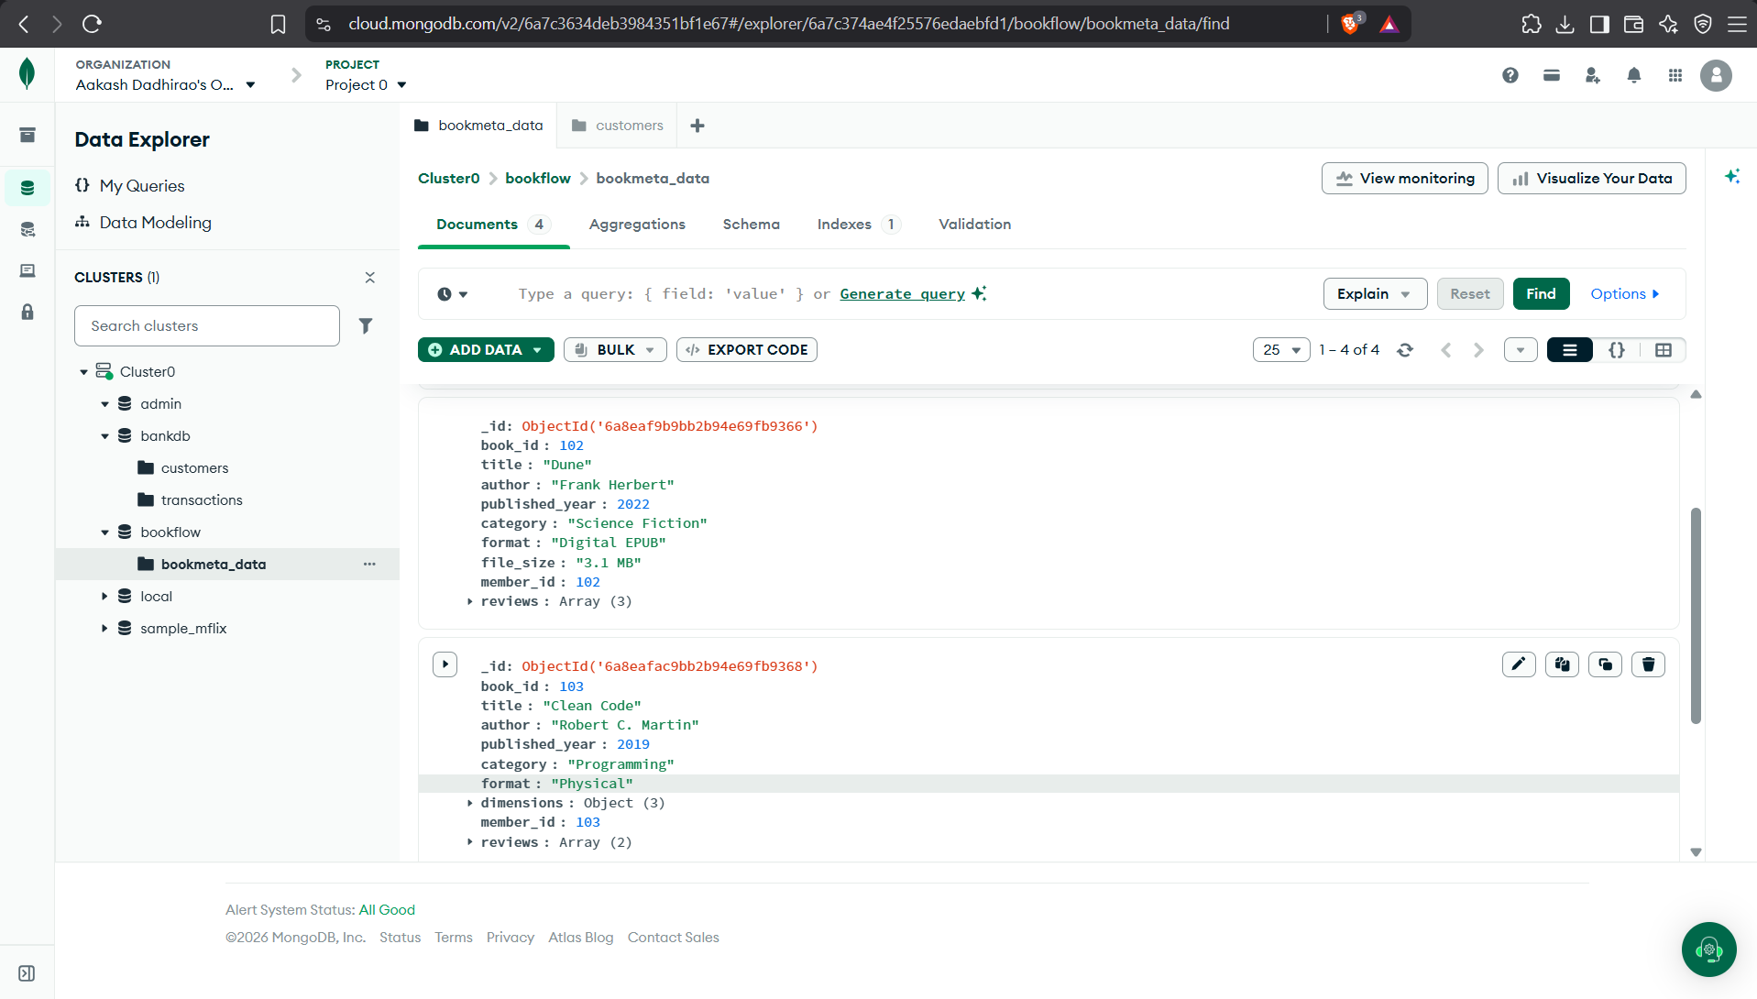

- Queries:
-> $gt
This checks for books having a review rating greater than 4. The result showed 5 documents.

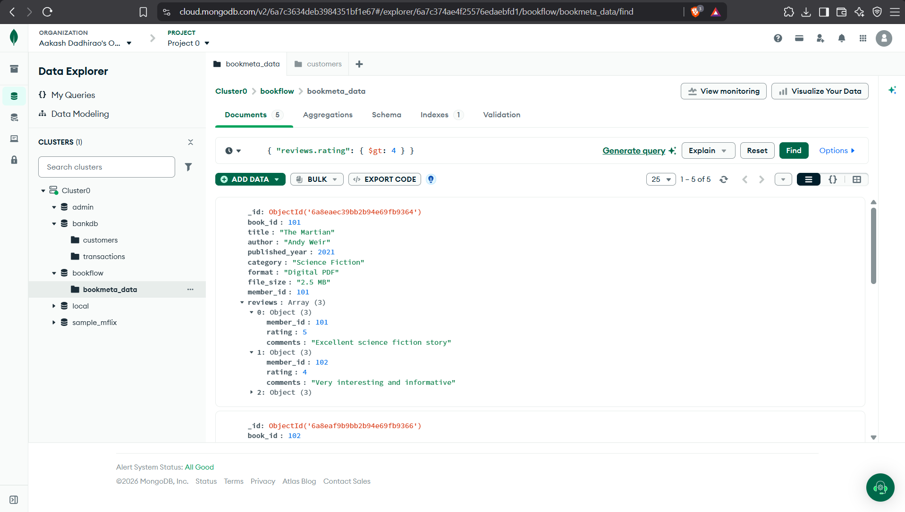

-> $in

This checks for ratings that are either 4 or 5. The result showed 5 documents.

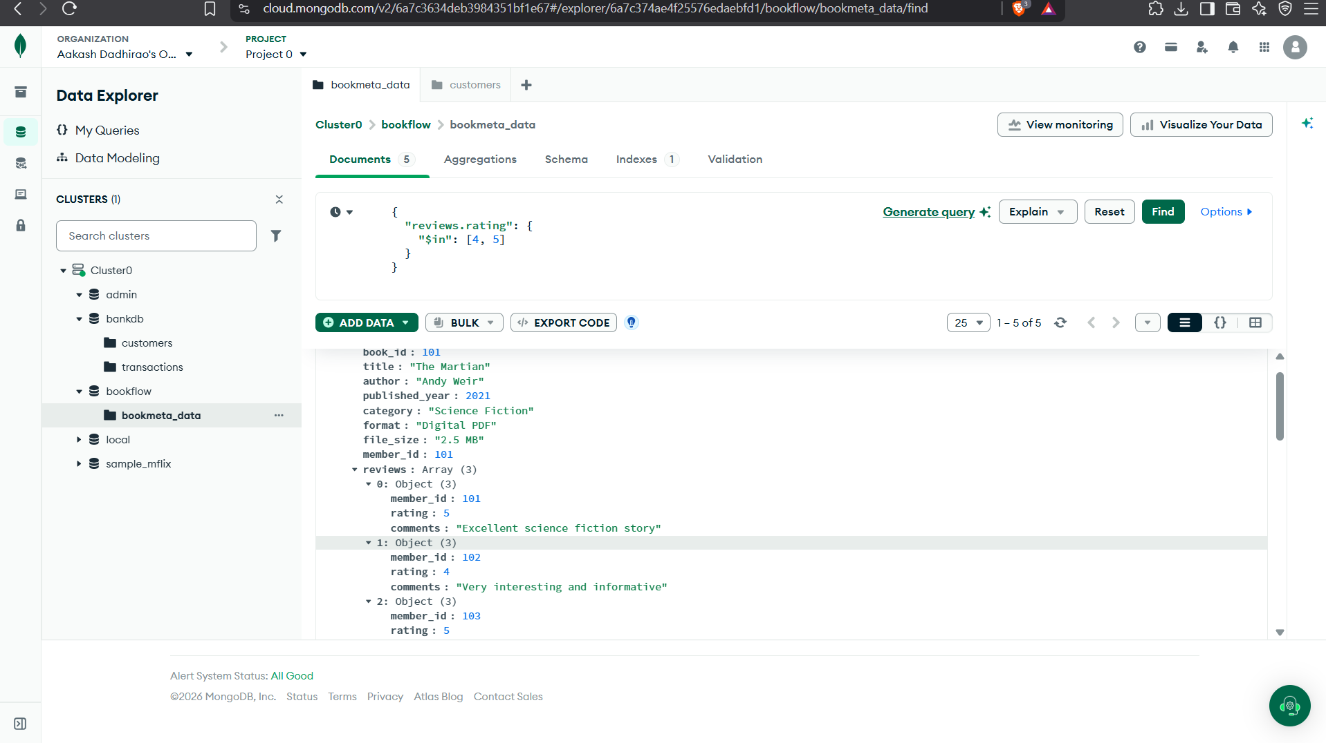

->Regex

This searches for Digital in the format field without worrying about uppercase/lowercase. 4 documents were returned.

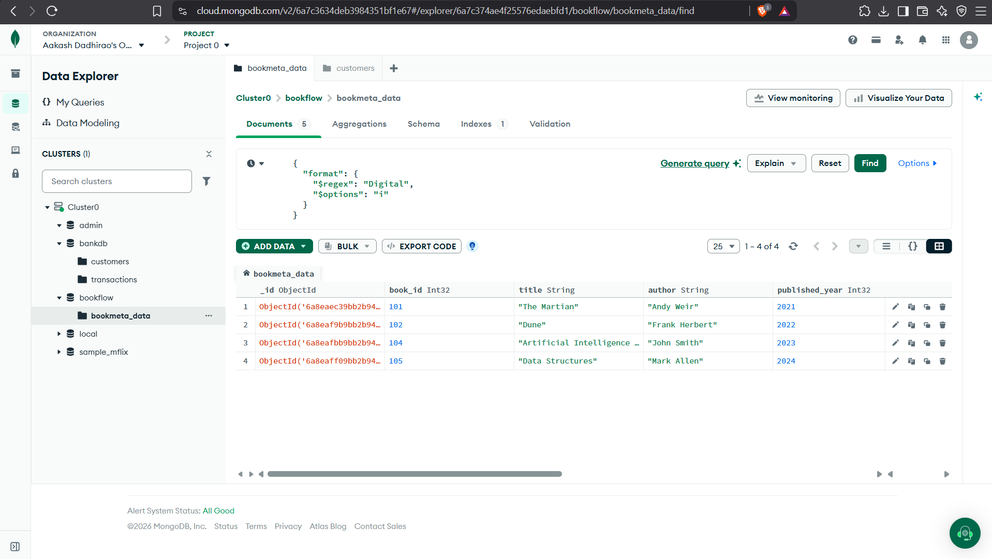

- Regex

I used the aggregation builder in Atlas and made the stages one by one.

-> $match
This filters the books published after 2020. The preview showed 4 documents.

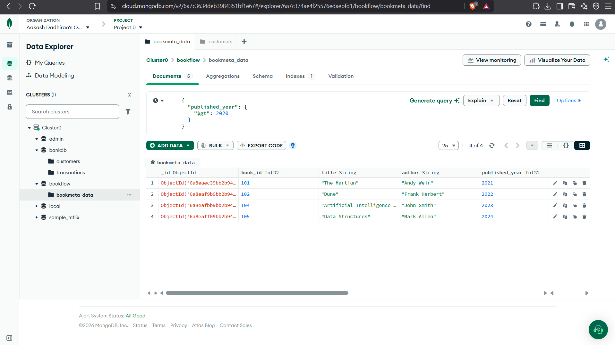
-> $unwind

This expands the reviews array so that each review can be handled separately.

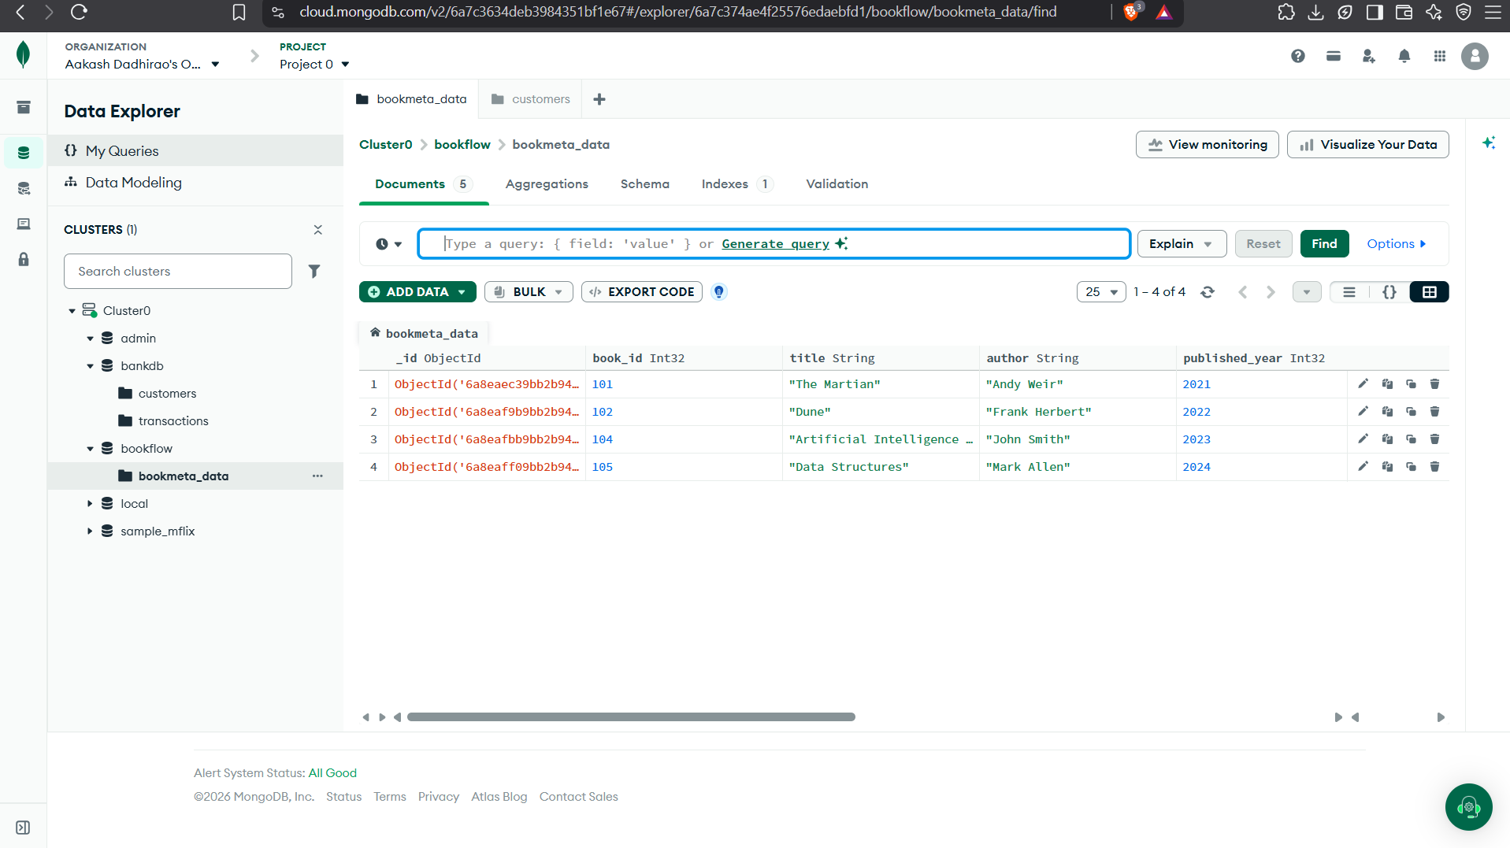

-> $group

This groups the reviews by book title and calculates the average rating and number of reviews.
Note: when I previewed this stage separately in Atlas, average_rating appeared as null because the $unwind stage was not before it in that separate preview. The stage itself is meant to be used after $unwind.

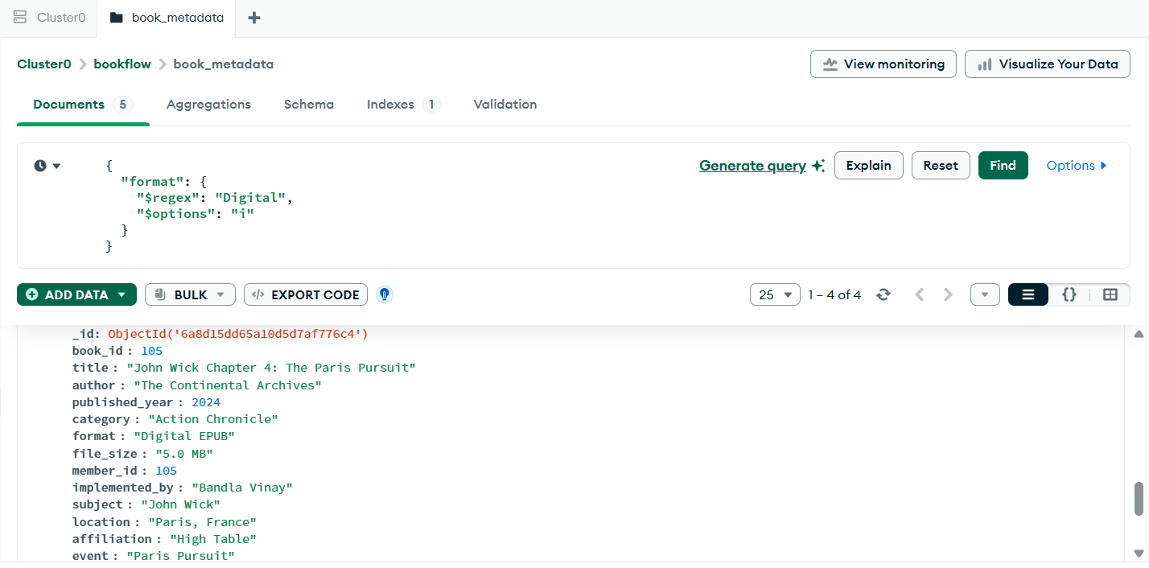

- Full Aggregation method:

So the order of the stages is: $match → $unwind → $group → $sort.

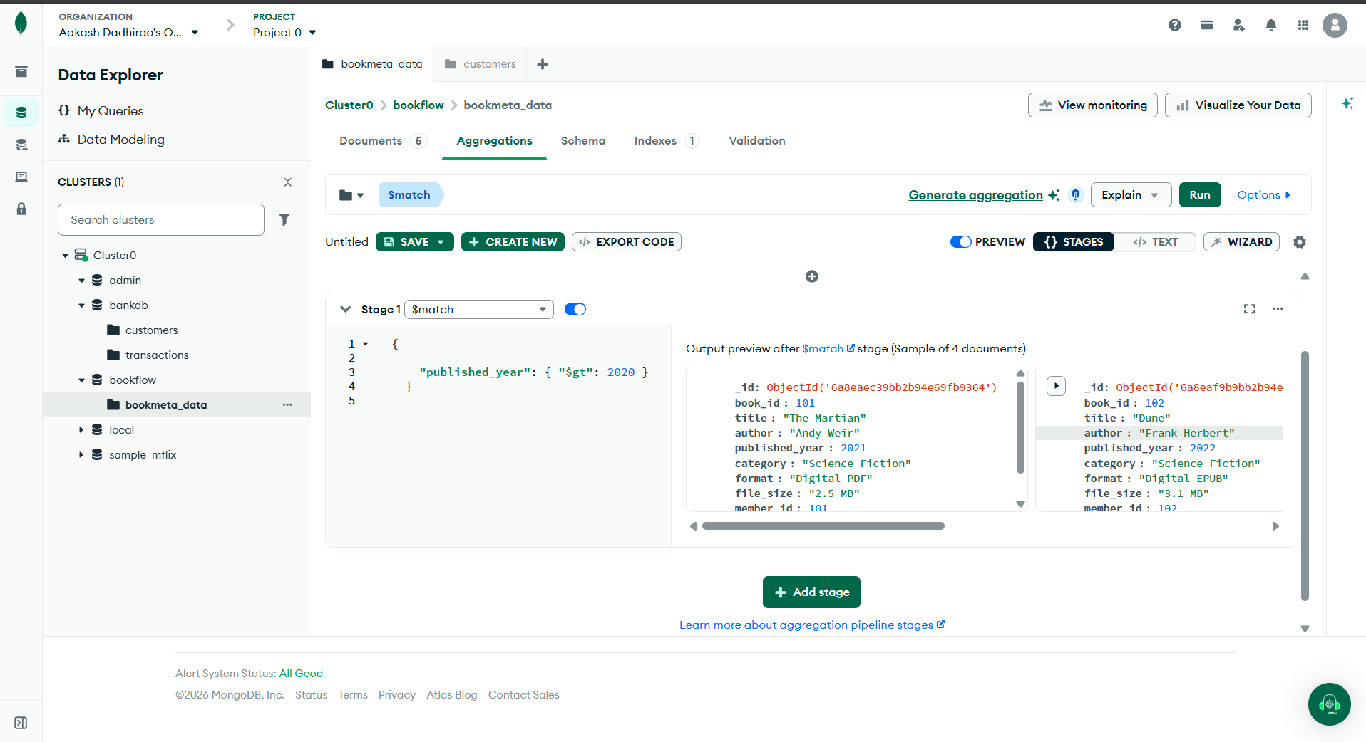

- Text Index

I created a text index on reviews.comments. In Atlas the index is shown as TEXT and its status is READY.

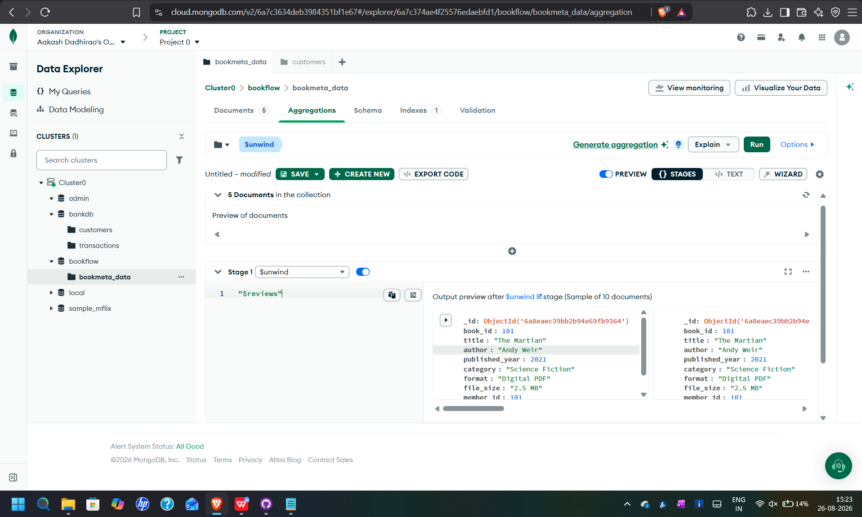

- Text Search

The text search for excellent returned 5 documents in the collection.

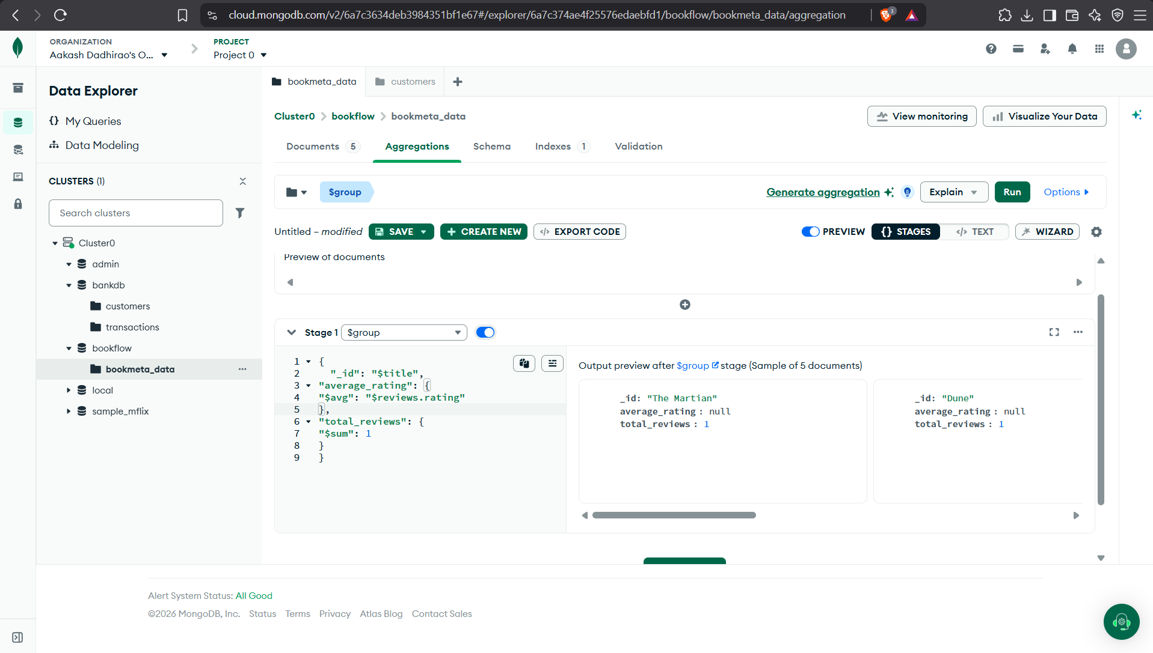

- Phrase Search:

The text search for excellent returned 5 documents in the collection.

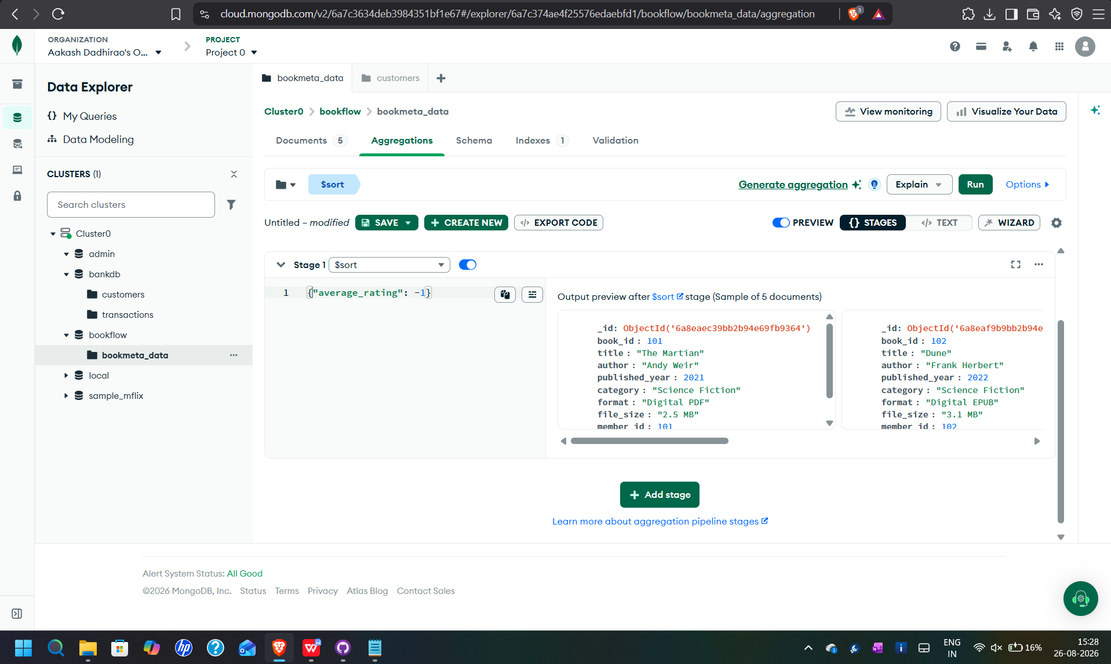

- Explain():
I also checked how MongoDB can show the query execution plan.
The main things to look for in the execution plan are IXSCAN, which means an index scan, and COLLSCAN, which means a collection scan.

- Result:
The MongoDB practical was completed using the book_metadata collection. I was able to perform the required queries, aggregation stages, text indexing and text searches in MongoDB Atlas.

- Conclusion:
This practical helped me understand how MongoDB stores flexible documents and how queries and aggregation can be applied to them. I also got to see how nested arrays can be searched and expanded using $unwind, and how a text index can be used for searching review comments.

